* Selecting a topic – Sentencing data from Cook County Government
* Finding a data set - <https://datacatalog.cookcountyil.gov/Courts/Sentencing/tg8v-tm6u>
* Finding inspiration – <https://demos.creative-tim.com/material-dashboard-dark/examples/dashboard.html>
* “Sketching” your ideal visuals –

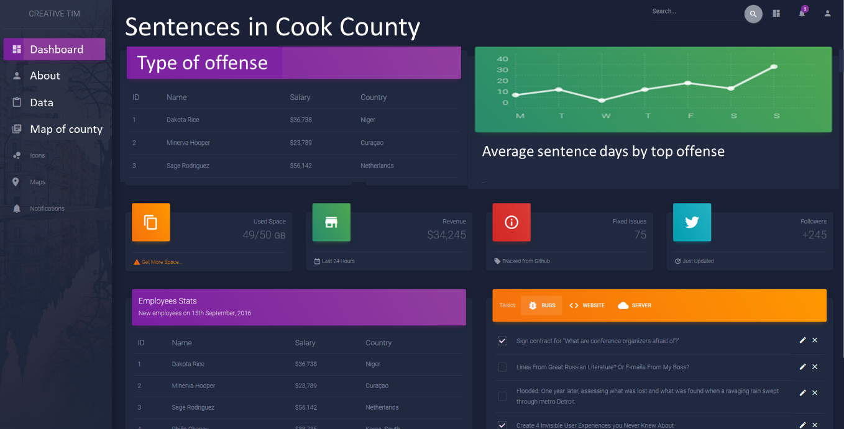

* Creating a 1-page proposal

* A brief articulation of your chosen topic and rationale – (paragraph by Purvi)
* A link to your data set(s) and a screenshot of the metadata if it exists.

<https://datacatalog.cookcountyil.gov/Courts/Sentencing/tg8v-tm6u>

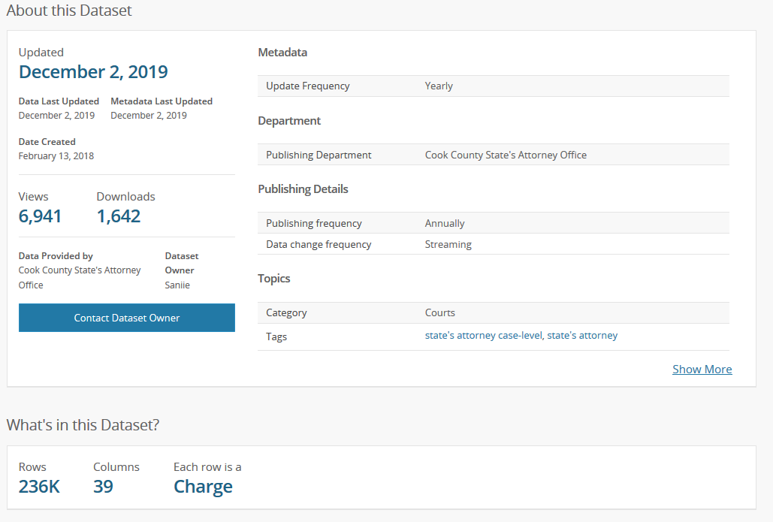

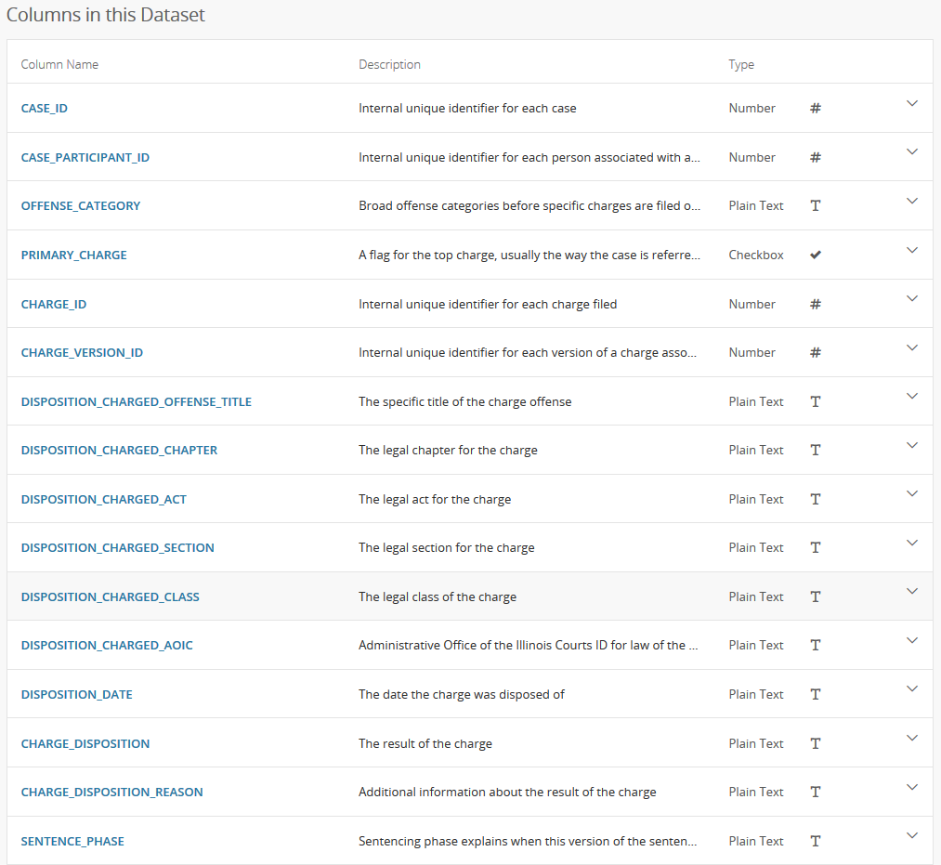

* 3 or 4 screenshots of relevant, “inspiring” visualizations that frame your creative fodder

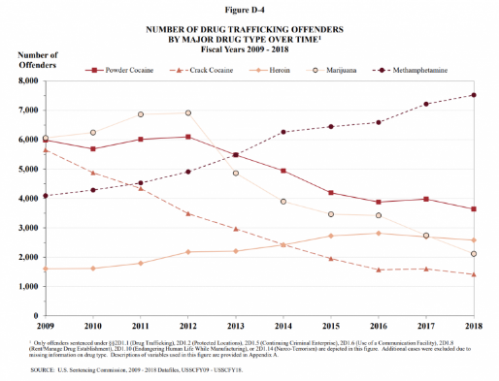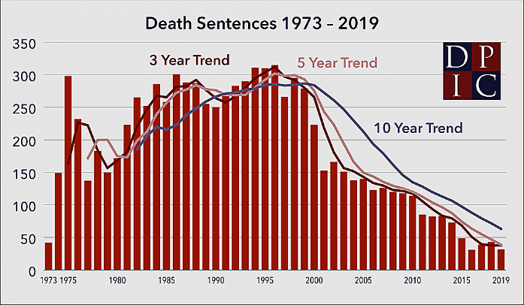

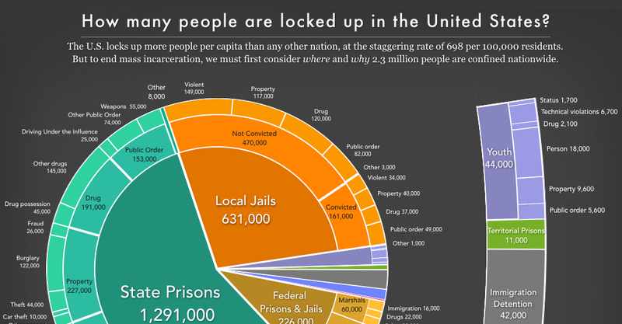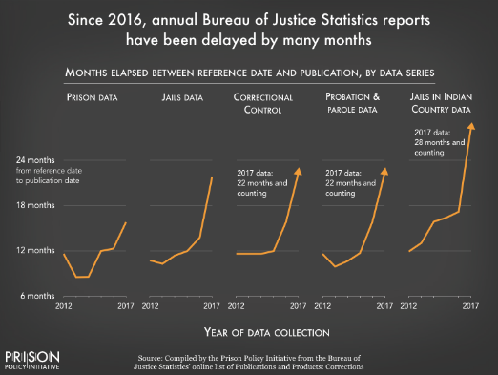

* A sketch of the final design –

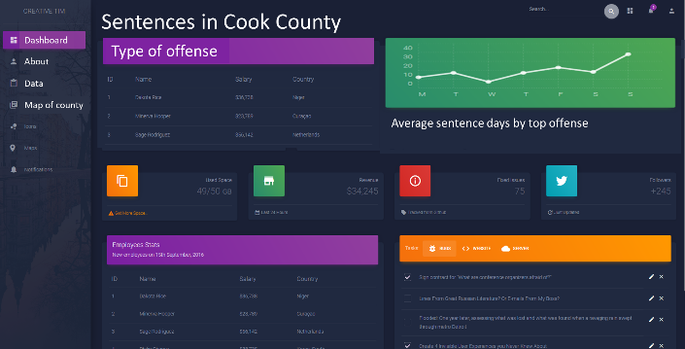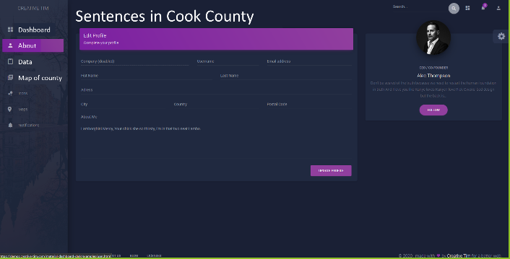

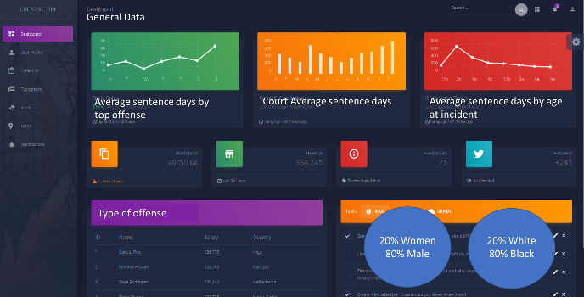

* A link to the primary GitHub repository you’ll be housing your work in - <https://github.com/cckuqui/CCSAO-Sentencing>